Build Tool
# Source: AI Source: Provided by: [Data Path: Persons Table -> ID Column: 1, Name_En Column: Motasem Essam] -> From: [ChatGPT] on [1/26/2026]
A Build Tool is a software tool that automates the process of compiling, testing, and packaging your code so it can be run or deployed.
It helps developers save time, avoid manual errors, and manage complex projects efficiently.

Key Functions of a Build Tool
# Source: AI Source: Provided by: [Data Path: Persons Table -> ID Column: 1, Name_En Column: Motasem Essam] -> From: [ChatGPT] on [1/26/2026]
- Compile code – Converts source code (like Java, Kotlin, or C++) into executable form.
- Run tests – Automatically runs unit or integration tests to ensure code works.
- Package the application – Creates distributable files like JARs, WARs, or ZIPs.
- Manage dependencies – Downloads libraries your project needs.
- Automate tasks – Can run tasks like code generation, minification, deployment, etc.

Examples
# Source: AI Source: Provided by: [Data Path: Persons Table -> ID Column: 1, Name_En Column: Motasem Essam] -> From: [ChatGPT] on [1/26/2026]
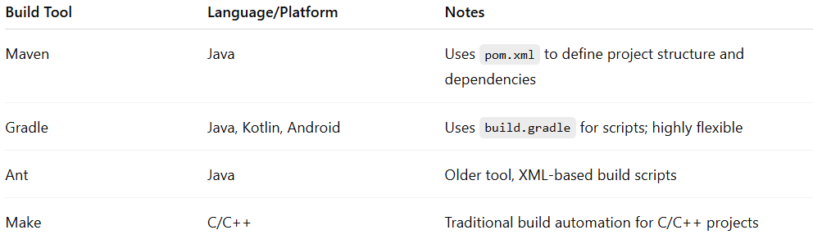
Build Tool | Language/Platform | Notes
Maven | Java | Uses pom.xml to define project structure and dependencies
Gradle | Java, Kotlin, Android | Uses build.gradle for scripts; highly flexible
Ant | Java | Older tool, XML-based build scripts
Make | C/C++ | Traditional build automation for C/C++ projects

Build Tool vs Dependency Manager
# Source: AI Source: Provided by: [Data Path: Persons Table -> ID Column: 1, Name_En Column: Motasem Essam] -> From: [ChatGPT] on [1/26/2026]
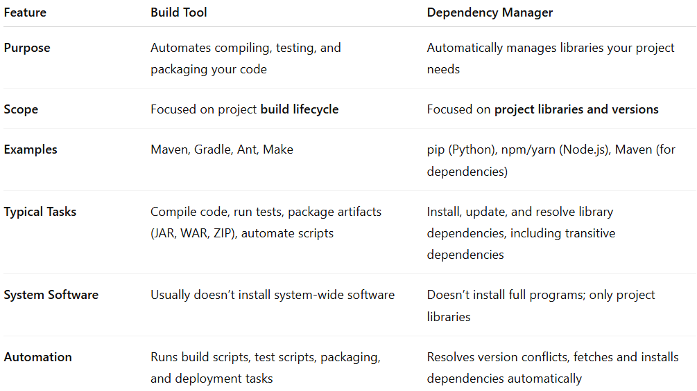
Feature | Build Tool | Dependency Manager
Purpose | Automates compiling, testing, and packaging your code | Automatically manages libraries your project needs
Scope | Focused on project build lifecycle | Focused on project libraries and versions
Examples | Maven, Gradle, Ant, Make | pip (Python), npm/yarn (Node.js), Maven (for dependencies)
Typical Tasks | Compile code, run tests, package artifacts (JAR, WAR, ZIP), automate scripts | Install, update, and resolve library dependencies, including transitive dependencies
System Software | Usually doesn’t install system-wide software | Doesn’t install full programs; only project libraries
Automation | Runs build scripts, test scripts, packaging, and deployment tasks | Resolves version conflicts, fetches and installs dependencies automatically

Key Points
# Source: AI Source: Provided by: [Data Path: Persons Table -> ID Column: 1, Name_En Column: Motasem Essam] -> From: [ChatGPT] on [1/26/2026]
- Build Tool: Focused on building and packaging your project.
- Dependency Manager: Focused on handling libraries and dependencies your project needs.
- Some tools can do both, making them extremely convenient for modern development workflows.

Software That Serves as Both Build Tool and Dependency Manager
# Source: AI Source: Provided by: [Data Path: Persons Table -> ID Column: 1, Name_En Column: Motasem Essam] -> From: [ChatGPT] on [1/26/2026]
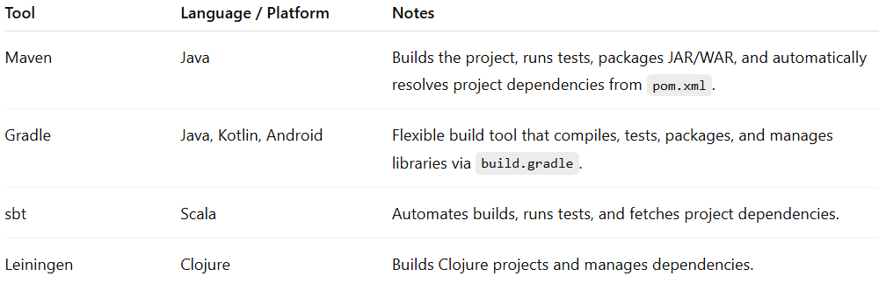
Tool | Language / Platform | Notes
Maven | Java | Builds the project, runs tests, packages JAR/WAR, and automatically resolves project dependencies from pom.xml.
Gradle | Java, Kotlin, Android | Flexible build tool that compiles, tests, packages, and manages libraries via build.gradle.
sbt | Scala | Automates builds, runs tests, and fetches project dependencies.
Leiningen | Clojure | Builds Clojure projects and manages dependencies.

✅ Summary
# Source: AI Source: Provided by: [Data Path: Persons Table -> ID Column: 1, Name_En Column: Motasem Essam] -> From: [ChatGPT] on [1/26/2026]
- A Build Tool automates compiling, testing, packaging, and deployment.
- It often integrates with dependency managers to automatically get required libraries.
- Essential for modern software development to ensure builds are consistent and repeatable.

